ARMSTRONG NUMBER

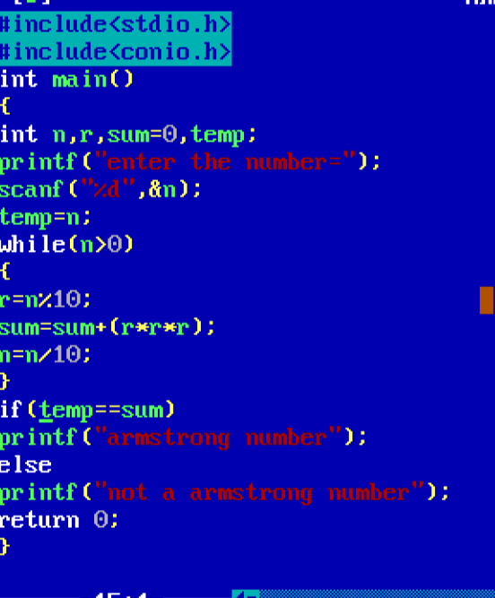

OUTPUT

